LAB -1
1)AIM: A rocket launch system displays a countdown before launch. Instead of using a loop implement the countdown using recursion .write a recursion python program to display a countdown from n to 1 followed by “launch”.
PROGRAM:
def launch(n):
for i in range(n,-1,-1):

if i==0:
print("launch")

else:
print(i)

n=int(input("enter no. of seconds to launch:"))
launch(n)

OUTPUT:
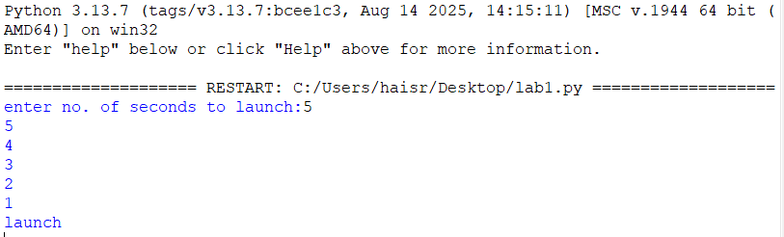

EXPLANATION:
This program displays a countdown from n to 1 and finally prints 'launch'. Although the aim mentions recursion, the given code uses a loop.

ERROR TABLE:
ERROR | CAUSE | SOLUTION
Indentation Error | Incorrect indentation | Align blocks properly
Name Error | Variable not defined | Define before use
Value Error | Non-integer input | Enter valid integer

2)AIM: banks calculate the growth of an investment using compoundinterest the formula requires calculating powers. Which can be implemented recursively. Write a recursive program to calculate p^n(power),where p=principal growth factor, n= number of years.
PROGRAM:
def intrest(p,n):
if n==0:
return 1
else:
return p*intrest(p,n-1)
n=int(input("enter no.of years:"))
p=int(input("enter a number:"))
res=intrest(p,n)
print(res)
OUTPUT:
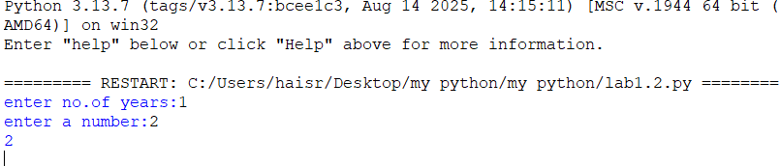EXPLANATION:This program recursively calculates p^n by multiplying p until n becomes 0.
ERROR TABLE:
ERROR | CAUSE | SOLUTION
Recursion error | Very large value of n | Reduce input
Name Error | Wrong function/variable name | Check spelling
Value Error | Non-integer input | Enter valid integer
3)AIM: An HR department stores employee ID’s in a list. Develop a recursive program to search for a given employee ID .write a recursive function to search for an employee ID in a list.
PROGRAM:
def search(m):

key=m
for i in range(n-1):
if arr[i]==key:
return i

n=int(input("enter no.of employees to add:"))
arr=[]
for i in range(n):
a=int(input("enter a value:"))
arr.append(a)
print(arr)
m=int(input("enter a element to search:"))
result=search(m)
if result==-1:
print(“element is not found”)
else:
print("employee id is stored at the index:",result)
OUTPUT:
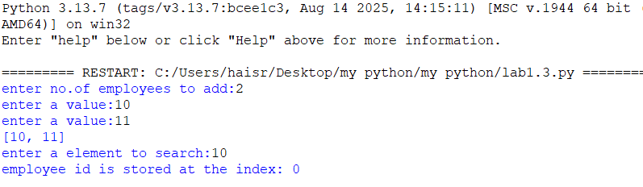

EXPLANATION:
This program searches for an employee ID in a list and returns its index if found.
ERROR TABLE:
ERROR | CAUSE | SOLUTION
Syntax error | Wrong quotes/brackets | Correct syntax
Logic error | Returns None instead of -1 | Return -1 when not found

4)AIM: In a logistics company the number of possible ways to arrange n different parcels is calculated using the factorial formula(n!). develop a recursive program to calculate the factorial of a given number.
PROGRAM:
def fact(n):
fact=1
for i in range(1,n+1):
fact=fact*i

return fact
n=int(input("enter a number to find its factorial:"))
result=fact(n)
print(result)
OUTPUT:
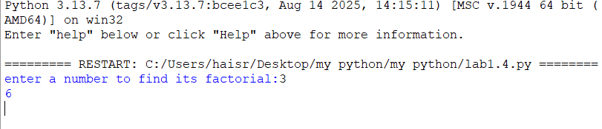

EXPLANATION:This program calculates the factorial of a number using iteration (not recursion).
ERROR TABLE:
ERROR | CAUSE | SOLUTION
Overflow/large input | Large input value | Give smaller input
Value error | Invalid input | Even integer

5)AIM: write a recursive python program to print the first n terms of the Fibonacci series.
PROGRAM:
def fib(n):
if n==0:
return 0
elif n==1:
return 1
else:
return fib(n-1)+fib(n-2)

n=int(input("enter no of terms:"))
if n<=-1:
print("invalid input")
else:
for i in range(n):
print(fib(i),end=" ")
OUTPUT:
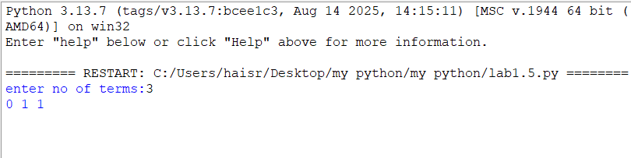
EXPLANATION:
The program uses recursion to generate Fibonacci numbers. fib (0)=0 and fib (1) =1 are the base cases. For every other term, fib(n)=fib(n-1) + fib(n-2). The loop prints the first n terms.

ERROR TABLE:
ERROR | CAUSE | SOLUTION
Recursion error | Large value of n | Use iteration
Invalid input | Negative value of n | Validate input
Slow execution | Repeated recursive calls | Use dynamic programming

PROGRAM | TIME COMPLEXITY | SPACE COMPLEXITY | REASON
1.countdown to launch |  |  | The program uses a loop that prints from n to 0 once.
  O(n)
  O(1)
2.power calculation |  |  | One recursive call is made for each value of n. The recursion stack stores n calls.
  O(n)
  O(n)
3.employee ID search |  |  | The program performs a linear search through the list.
  O(n)
  O(1)
4.Factorial |  |  | The program calculates factorial using a loop from 1 to n.
  O(n)
  O(1)
5.Fibonacci series
  O(2ⁿ)
  O(n)
  Each function call creates two more recursive calls, leading to exponential time. The recursion stack reaches depth n.

LAB-2

1.AIM: Write a program to perform linear search on a given input.
PROGRAM:
def linear_search(arr,key):
for i in range(len(arr)):
if arr[i]==key:
return i
return -1

n = int(input("Enter no. of elements:"))
arr=[]
print("Enter the elements:")
for i in range(n):
arr.append(int(input()))
key=int(input("Enter element to search:"))
result=linear_search(arr,key)
if result!=-1:
print("Element found at index",result)
else:
print("Element not found.")
OUTPUT:

EXPLANATION:
- The linear_search() function checks each element of the list one by one and compares it with the given key.
- If the key is found, its index is returned; otherwise, the function returns -1.
- The program takes the array and search element as input and displays whether the element is found.
ERROR TABLE:
S.no. | Errors | Rectification
1. | ValueError occurs if a non-integer value is entered when int(input()) is used. | Enter only integer values for the number of elements and array elements.
2. | TypeError may occur if len(arr) is used on a variable that is not a list. | Make sure arr is initialized as a list using arr = [] and elements are appended to it.

2.AIM: Write a Python program to perform binary search on the given input. Verify by taking sorted array and unsorted array as input.
PROGRAM:
def binary_search(arr,key):
low=0
high=len(arr)-1
while low<=high:
mid=(low+high)//2
if arr[mid]==key:
return mid
elif arr[mid]<key:
low=mid+1
else:
high=mid-1
return -1

n = int(input("Enter no. of elements:"))
arr=[]
print("Enter the elements:")
for i in range(n):
arr.append(int(input()))

key=int(input("Enter element to search:"))
result=binary_search(arr,key)
if result!=-1:
print("Element found at index",result)
else:
print("Element not found.")
OUTPUT:

3.PROGRAM:
def binary_search(arr,key):
low=0
high=len(arr)-1
while low<=high:
mid=(low+high)//2
if arr[mid]==key:
return mid
elif arr[mid]<key:
low=mid+1
else:
high=mid-1
return -1

n = int(input("Enter no. of elements:"))
arr=[]
print("Enter the elements:")
for i in range(n):
arr.append(int(input()))
if arr==sorted(arr):
print("\n The input list is already sorted.")
else:
print("\n The input list is not sorted.")
print("Sorting the list...")
arr.sort()
print("Sorted list.",arr)
key=int(input("Enter element to search:"))
result=binary_search(arr,key)
if result!=-1:
print("Element found at index",result)
else:
print("Element not found.")
OUTPUT:
EXPLANATION:
- The binary_search() function repeatedly divides the sorted list into two halves and compares the middle element with the search key.
- If the middle element is smaller than the key, the search continues in the right half; otherwise, it searches the left half.
- The second program verifies whether the input is sorted and sorts it using arr.sort() if necessary before performing binary search.

ERROR TABLE:
S.no. | Errors | Rectification
1. | Binary search may give an incorrect result if the input array is unsorted. | Check whether the array is sorted and use arr.sort() before calling binary_search().
2. | IndexError can occur if mid is calculated or the low/high boundaries are modified incorrectly. | Initialize low = 0, high = len(arr) - 1 and update them as low = mid + 1 or high = mid - 1.

